http://www.prodigyproductionsllc.com/articles/automation/windows-automation-with-c/

Download UISpy from [here](http://www.prodigyproductionsllc.com/wp-content/uploads/2011/03/uispy.zip). UISpy is a simple tool to interrogate the desktop application

Interrogate application to get names

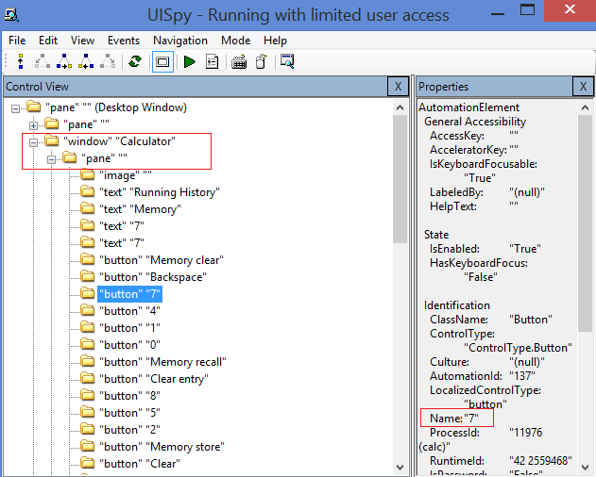

Include in reference

UIAutomationClient.dll

UIAutomationTypes.dll

Browse the files in

C:\Windows\Microsoft.NET\Framework64\v4.0.30319\WPF

using System;

using System.Collections.Generic;

using System.ComponentModel;

using System.Data;

using System.Drawing;

using System.Linq;

using System.Text;

using System.Windows.Forms;

using System.Reflection;

using System.Windows.Automation;

using System.Threading;

using Automation = System.Windows.Automation;

namespace UIAutomation

{

public partial class MainForm : Form

{

private Thread autoThread;

public MainForm()

{

InitializeComponent();

}

private void MainForm_FormClosing(object sender, FormClosingEventArgs e)

{

if (autoThread != null && autoThread.IsAlive)

{

autoThread.Join();

autoThread.Abort();

}

}

// create new thread

**private void btnStart_Click(object sender, EventArgs e)**

{

System.Diagnostics.Process.Start("calc.exe");

autoThread = new Thread(new ThreadStart(Automate));

autoThread.Start();

}

**private void Automate()**

{

LogMessage("Getting RootElement...");

AutomationElement rootElement = AutomationElement.RootElement;

if (rootElement == null)

{

LogMessage("Error, root Element not found");

return;

}

LogMessage("Searching for Calculator Window...");

Automation.Condition condition = new PropertyCondition(AutomationElement.NameProperty, "Calculator");

AutomationElement appElement = rootElement.FindFirst(TreeScope.Children, condition);

if (appElement == null)

{

LogMessage("Error Application not found");

return;

}

LogMessage("Searching for the 7 button...");

Automation.Condition btn7Condition = new PropertyCondition(AutomationElement.NameProperty, "7");

AutomationElement btn7 = appElement.FindFirst(TreeScope.Children, btn7Condition);

if (btnSeven == null)

{

LogMessage("Error Button 7 not found");

return;

}

InvokePattern btn7Pattern = btn7.GetCurrentPattern(InvokePattern.Pattern) as InvokePattern;

LogMessage("Clicking the 7 button");

Btn7Pattern.Invoke();

LogMessage("OK.");

}

#region Cross Thread Control Delegates  
 delegate void SetValueDelegate(Object obj, Object val, Object[] index);  
 private void SetControlProperty(Control ctrl, String propName, Object val)  
 {  
 PropertyInfo propInfo = ctrl.GetType().GetProperty(propName);  
 Delegate dgtSetValue = new SetValueDelegate(propInfo.SetValue);  
 ctrl.Invoke(dgtSetValue, new Object[3] { ctrl, val, /*index*/ null });  
 }

delegate object GetText(Control ctrl, String propName);  
 private object GetControlProperty(Control ctrl, String propName)  
 {  
 return ctrl.GetType().GetProperty(propName).GetValue(ctrl, null);  
 }  
#endregion

private void LogMessage(String message)

{

string tempText = txtConsole.Invoke(new GetText(GetControlProperty),

txtConsole, "Text").ToString(;

SetControlProperty(txtConsole, "Text", tempText + message + Environment.NewLine);

}

}

}

[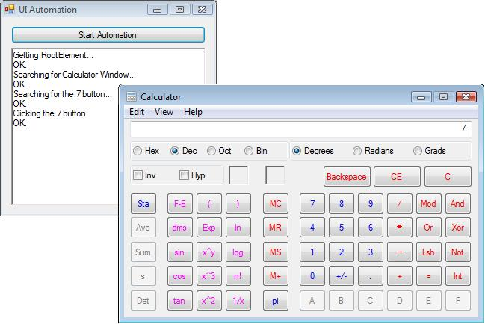](http://www.prodigyproductionsllc.com/wp-content/uploads/2011/03/calculator_automation.jpg)